

**Biography**

|  |  |  |
| --- | --- | --- |
| **Supervisor:** | *LE THANH NHAN* | |
| **Semester:** | *01* | |
| **Batch No:** | *T5.2303.E0* | |
| **Group No:** | *04* | |
| **Order:** | **Full name** | **Roll No.** |
| *1.* | *Pham Hoai Nhan* | *Student1468188* |
| *2.* | *Nguyen Quang Huy* | *Student1468178* |
| *3.* | *Truong Nguyen Nguyen Chuong* | *Student1468205* |
| *4.* | *Dang Thi Bich Nga* | *Student1468184* |

***Month****: 06* ***Year****: 2023*



This is to certify that

|  |  |
| --- | --- |
| **Mr.** | **PHAM HOAI NHAN** |
| **Mr.** | **NGUYEN QUANG HUY** |
| **Mr.** | **TRUONG NGUYEN NGUYEN CHUONG** |
| **Ms.** | **DANG THI BICH NGA** |

Have successfully Designed & Developed

|  |  |  |
| --- | --- | --- |
|  |  |  |
| **BIOGRAPHY OF**  **MARIE CURIE** | | |

Submitted by:

|  |
| --- |
| **Mr. LE THANH NHAN** |

Date Of Issue:

|  |  |
| --- | --- |
|  |  |

Authorized Signature:

|  |  |
| --- | --- |
|  |  |

|  |
| --- |
| **Content** |

Content

Acknowledge

Synopsis

Review1 (1)

Review2 (5)

Review3 (điền số trang theo thực tế)

Testing Document (điền số trang theo thực tế)

Final Checklist (điền số trang theo thực tế)

Task sheet (11)

|  |
| --- |
| **Acknowledge** |

As we understand that the eProject is a step-by-step learning environment that closely simulates the classroom and Lab based learning environment into actual implementation. This is also the first eProject we received from India. This is a playground for all students to get closer together and unleash their full potential. Through this project, we can practice creating an actual website step by step. This requires us to apply the knowledge learned in class and learn new abilities to be close to reality. Difficulties and errors in the working process are inevitable. However, eProject gives us the following:

✓ Apply theory to practice and practice step by step.

✓ Build a more extensive, more robust application.

✓ Unleash the hidden potential in each individual.

✓ Single program to unified code leading to a complete application.

✓ Developing teamwork skills.

✓ Work on real-life projects.

✓ Give a real-life scenario and help create more complicated and valuable applications.

Thank you to our professor "Nguyen Thanh Nhan" for always guiding us every step of the way during the project. I have learned a lot from professional knowledge, research skills, professional, ethical values, and severe thinking in project implementation. He is not only a guide for research work but also someone who instills in us a high sense of responsibility, passion, and desire to progress in our field. The words of encouragement, comments, and suggestions from teachers have helped me to complete and improve the quality of the project. In addition, we also want to thank our classmates for their advice and support during the one month of the project. We also thank you so much for your information and the "demo" project from India APTECH to help us get a more realistic experience in this project. We hope to see you soon in the next project. I have learned a lot since doing this eProject. This will always be the luggage for us to continue pursuing the path of becoming a professional full-stack.

You are Sincere

Team Group No.04.

|  |
| --- |
| **Synopsis** |

Our goal is to put what we have learned into practice. Using HTML/JAVASCRIPT tools, we can build a web profile of a particular individual. The website (in this project) is a tool that provides a full biography of Marie Curie - the famous scientist who won the Nobel Prize.   
This website will provide all the information about life and what revolves around the main character. This website will help users understand all the information about celebrities and create a community for people to interact and exchange information, one of the crucial things we must focus on. Come to find out more about the issues related to this topic.   
 And get back to eprojects@aptech.ac.in as the assigned schedule.

|  |
| --- |
| **Problem Definition** |

Famous people are people with many achievements and influence on society. So, biographies of famous people are also fascinating. In today's highly developed industry, we can use the Internet to learn about famous people. Therefore, the team wants to dissolve what they have learned about programming to create a website to collect and share information with readers. From the people's stories, our team wants to inspire so many people, helping everyone better understand their lives and the outstanding achievements they have brought to this world.

Celebrity Biography is the category that our team wants to aim for this project. And specifically, we are making a website about the Biography of Marie Curie - Winner of two Nobel prizes and the first woman ever to win a Nobel.

This website will be developed for the Windows Platform using HTML5, JavaScript, and Geolocation. The website will work fine in all the leading browsers, including Chrome, IE, Firefox, etc. Our website provides her personal information, books, and achievements... Our problem was finding a way to display the data in detail and succinctly—speakers' information on the display page. Then we must arrange the order on the navigation bar to make it easy for users to use. The interface on the website is also discussed and considered by us.

|  |  |  |  |  |  |  |  |  |  |  |  |  |  |  |  |
| --- | --- | --- | --- | --- | --- | --- | --- | --- | --- | --- | --- | --- | --- | --- | --- |
| |  | | --- | | **Customer Requirements Specifications** |  |  |  | | --- | --- | | **User:** | | |  | **Input:** | |  | * Choose the links * Choose the books * Enter keywords | |  | **Process:** | |  | * Navigate user to the destinated page * Navigate user to the book page * Filter keywords within the webpage. | |  | **Output:** | |  | * Display the content of the page * Display content of the destinated page * Highlight the filtered keywords. | |

|  |  |
| --- | --- |
| **Hardware / software requirement:** | |
|  | **Software:** |
|  | * Notepad / HTML editor / CoffeeCup * Angular / Angular JS / React / BootStrap * Dreamweaver / Figma * MS IE / Chrome / FireFox / Netscape / MS Edge |
|  | **Hardware:** |
|  | * A minimum computer system that will help you access all the tools in the courses is a Pentium 166 or better * 64 Megabytes of RAM or better. |

|  |
| --- |
| **Architecture and design of the project** |

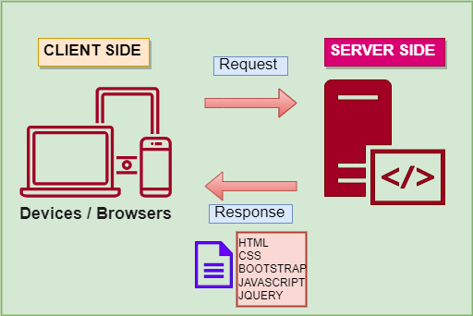

|  |
| --- |
| **Site Map** |

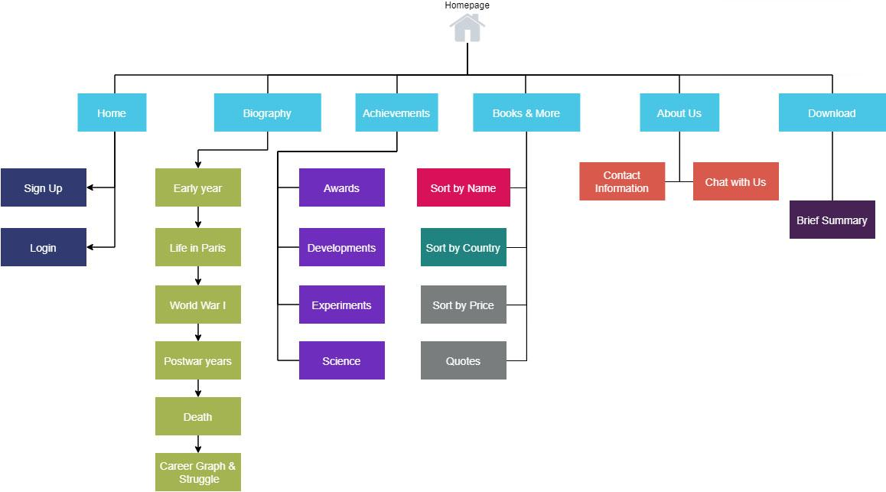

|  |
| --- |
| **Screen shots** |

1. **Homepage:**

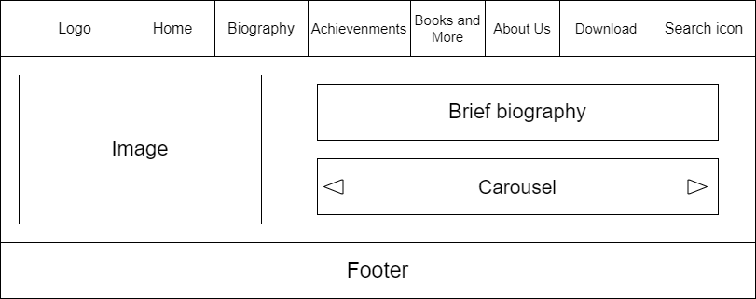

**Description** : This is the main screen, used to display information and links to other pages.

**From** : Opened from the home.html

**To** : Biography,Achievements ,Books and More, About Us, Download

**II. Biography**

1. Childhood

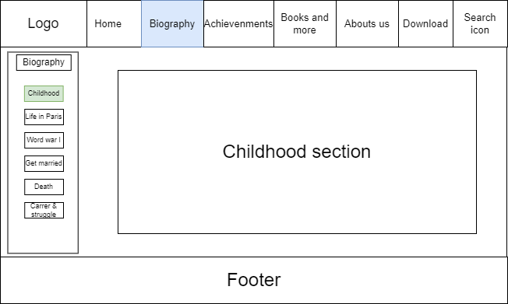

**Description** : This is a biography screen with a small section called childhood, used to display information and links to other pages.

**From** : Opened from the Biography.html

**To** : Home, Achievements, Books and More, About Us, Download

2. Life in Paris

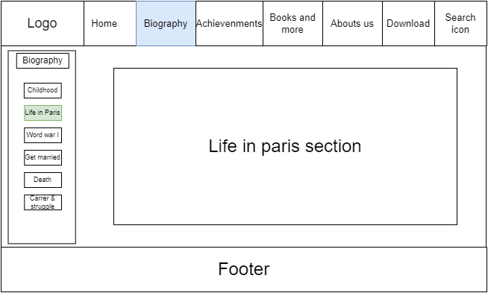

**Description** : This is a biography screen with a small section called life in Paris, used to display information and links to other pages.

**From** : Opened from the Biography.html

**To** : Home, Achievements, Books and More, About Us, Download

3. Word war I

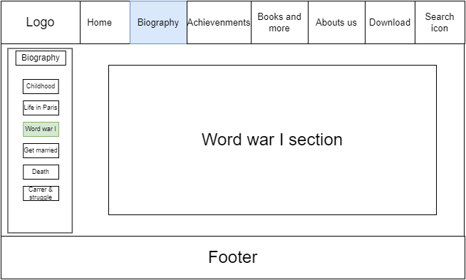

**Description** : This is a biography screen with a small section called “word war I”, used to display information and links to other pages.

**From** : Opened from the Biography.html

**To** : Home, Achievements, Books and More, About Us, Download

4. Get married

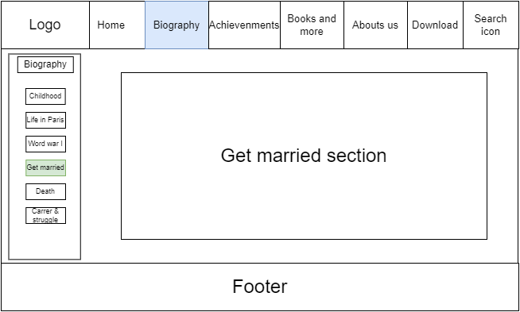

**Description** : This is a biography screen with a small section called “get married”, used to display information and links to other pages.

**From** : Opened from the Biography.html

**To** : Home, Achievements, Books and More, About Us, Download.

5.Death

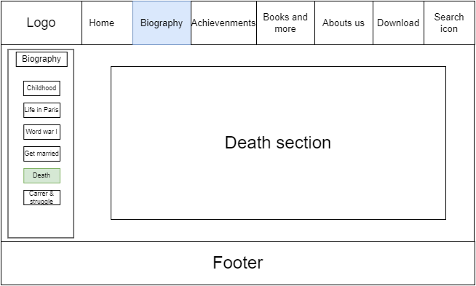

**Description** : This is a biography screen with a small section called “Death”, used to display information and links to other pages.

**From** : Opened from the Biography.html

**To** : Home, Achievements, Books and More, About Us, Download

6. Career graph and struggle

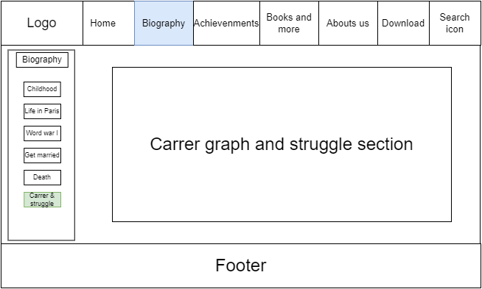

**Description** : This is a biography screen with a small section called “Career & struggle”, used to display information and links to other pages.

**From** : Opened from the Biography.html

**To** : Home, Achievements, Books and More, About Us, Download can reach

1. **Achievement**

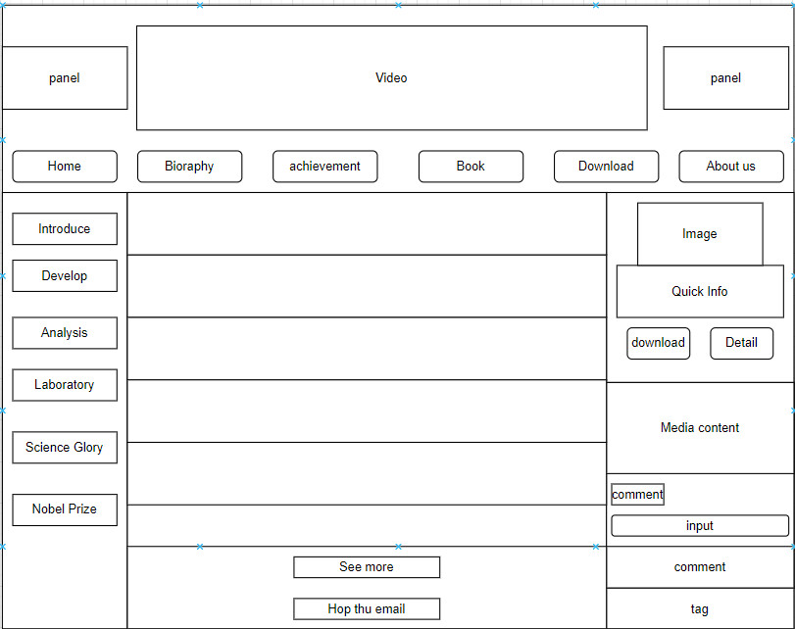

**Description** : This is an achievement page that tells you Marie Curie's life achievements

**From** : Home > Achievement

**To** : Introduce, develop, research, science, Nobel prize, See more

**IV. Books and more**

1.1

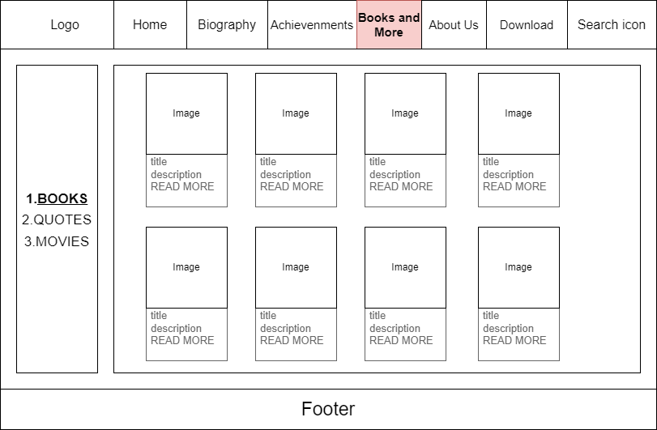

**Description** : This is the Books and More sections. This section describes books and quotes. Also the details of books and how to purchase them.

**From** : Homepage > books and more

**To** : This page can direct to

1. Quote.html
2. Movie.html
3. Homepage

1.2

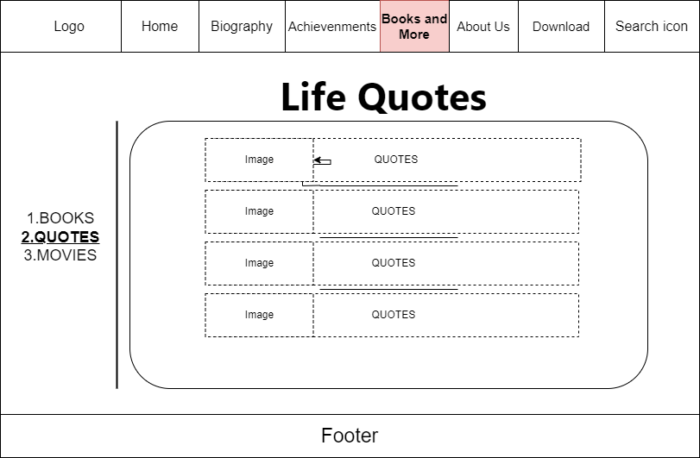

**Description** : This is the Quotes page, used to show details of all the famous quotes of Marie Curie.

**From** : Homepage > Books and more > Quotes

**To** : This page can direct to:

1. Book.html
2. Movie.html
3. Homepage

1.3

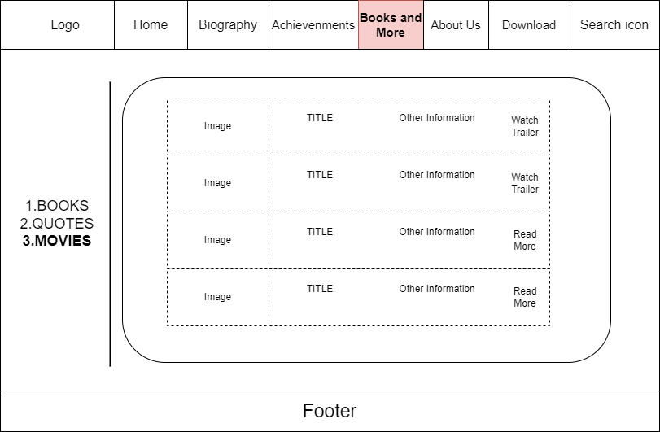

**Description** : This is the Quotes page, used to show details of all the famous quotes of Marie Curie.

**From** : Homepage > Books and more > Quotes

**To** : This page can direct to:

1. Book.html

2. Movie.html

3. Homepage

**V. Abouts us**

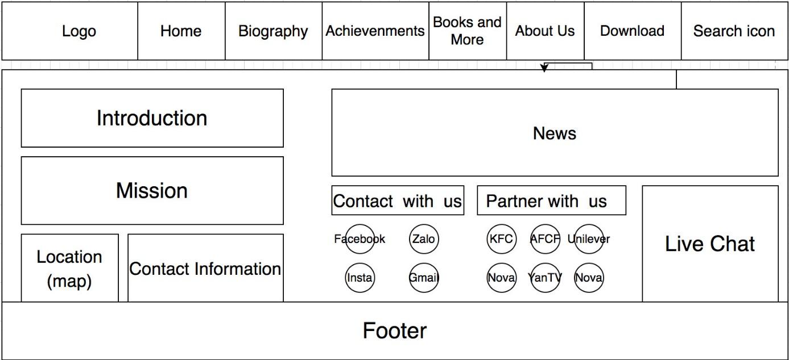

**Description** : Description about company information, mission, news and contact method.

**From** : Home > About Us

**To** : Introduction, mission, news, live chat, contact with us, partner with us, location, contact information

**VI. Download**

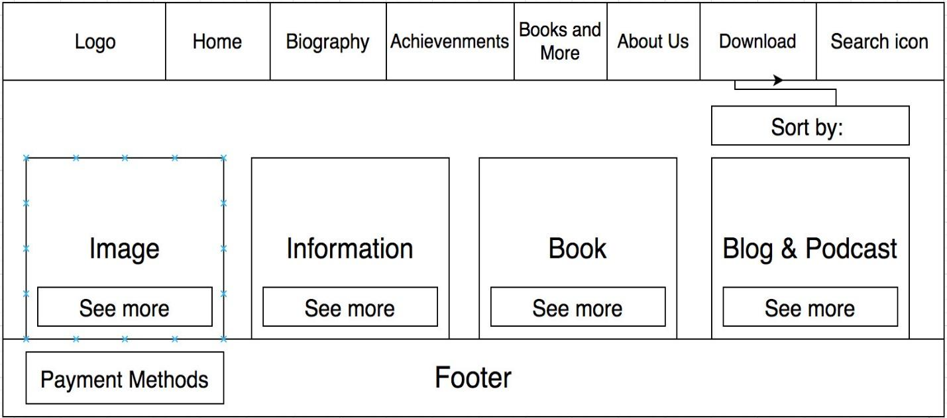

**Description** : Description of company information, mission, news and contact method Download images, information, books and podcasts related to the author.

**From** : Download

**To** : Image ⇒ see more ⇒ download, Information ⇒ see more ⇒ download, Book ⇒ see more ⇒ download, Blog & Podcast ⇒ see more ⇒ download.

|  |
| --- |
| **Testing document** |

|  |  |  |
| --- | --- | --- |
| **Sr.No** | **Features Tested** | **Remarks** |
| 1 | Are all the users able to view the images and links? |  |
| 2 | Have all the views, modules and controllers been properly integrated and is the site function as a single page application? |  |
| 3 | Are the GUI content devoid of spelling mistakes? |  |
| 4 | Is the application user-friendly? |  |
| 5 | Is the Website launching correctly in all popular browsers? |  |
| 6 | Are all the forms validated with proper criteria? |  |
| 7 | Do all text links lead to the appropriate website? |  |
| 8 | Do all image links lead to the appropriate website? |  |
| 9 | Are all the images and links clearly visible on the page? |  |
| 10 | Does the Web page work properly in all the tested browsers? |  |
| 11 | Does the Web page take too long to be loaded fully? |  |
| 12 | Is the navigation sequences correct through all the Web pages on the site? |  |
| 13 | Is the JavaScript code working as expected in all click events? |  |
| 14 |  |  |
| 15 |  |  |

|  |
| --- |
| **Final checklist** |

|  |  |  |
| --- | --- | --- |
| **Sr.No** | **Aspected Tested** | **Suggestion/**  **Remarks** |
| 1 | Are all the users able to view the images and links? |  |
| 2 | Have all the views, modules and controllers been properly integrated and is the site function as a single page application? |  |
| 3 | Are the GUI content devoid of spelling mistakes? |  |
| 4 | Is the application user-friendly? |  |
| 5 | Is the Website launching correctly in all popular browsers? |  |
| 6 | Are all the forms validated with proper criteria? |  |
| 7 | Do all text links lead to the appropriate website? |  |
| 8 | Do all image links lead to the appropriate website? |  |
| 9 | Are all the images and links clearly visible on the page? |  |
| 10 | Does the Web page work properly in all the tested browsers? |  |
| 11 | Does the Web page take too long to be loaded fully? |  |
| 12 | Is the navigation sequences correct through all the Web pages on the site? |  |
| 13 | Is the JavaScript code working as expected in all click events? |  |
|  |  |  |
|  |  |  |

|  |  |  |  |  |  |  |  |
| --- | --- | --- | --- | --- | --- | --- | --- |
| **No** | **Member** | **Contents** | **Page Name** | **Activity Plan** | **Date of Preparation of Activity Plan** | | |
| **Planned Start Date** | **Actual Start Date** | **Actual Days** | **Status** |
| 1 | Pham Hoai Nhan | Achievements | Achievements.html | 12-06-2023 | 13-06-2023 |  | OK |
| 2 | 12-06-2023 | 13-06-2023 |  | OK |
| 1 | Nguyen Quang Huy | Home | Home.html | 12-06-2023 | 13-06-2023 |  | OK |
| 2 | Biography | Biography.html | 12-06-2023 | 13-06-2023 |  | OK |
| 1 | Truong Nguyen Nguyen Chuong | Book  Quote  Movie | Books.html | 12-06-2023 | 13-06-2023 |  | OK |
| 2 | Quote.html | 12-06-2023 | 13-06-2023 |  | OK |
| 3 | Movie.html | 12-06-2023 | 13-06-2023 |  | OK |
| 1 | Dang Thi Bich Nga | About us | AboutUs.html | 12-06-2023 | 13-06-2023 |  | OK |
| 2 | Download | Download.html | 12-06-2023 | 13-06-2023 |  | OK |